EXP 1-DES (Data Encryption Standard)
Aim
- To implement the Data Encryption Standard (DES) algorithm for encryption and decryption.
Algorithm
- Read 64-bit plaintext.
- Divide into two 32-bit halves.
- Perform 16 rounds of permutation and substitution.
- Swap left and right halves.
- Apply final permutation to obtain ciphertext.
Code
import javax.crypto.Cipher;
import javax.crypto.KeyGenerator;
import javax.crypto.SecretKey;
import java.util.Base64;

public class DESDemo {

public static void main(String[] args) throws Exception {

String plainText = "HELLO";

// Generate DES Key
KeyGenerator keyGenerator = KeyGenerator.getInstance("DES");
keyGenerator.init(56);
SecretKey secretKey = keyGenerator.generateKey();

// Encryption
Cipher cipher = Cipher.getInstance("DES");
cipher.init(Cipher.ENCRYPT_MODE, secretKey);
byte[] encryptedBytes = cipher.doFinal(plainText.getBytes());

// Convert encrypted bytes to Base64
String encryptedText = Base64.getEncoder().encodeToString(encryptedBytes);

// Decryption
cipher.init(Cipher.DECRYPT_MODE, secretKey);
byte[] decryptedBytes = cipher.doFinal(Base64.getDecoder().decode(encryptedText));
String decryptedText = new String(decryptedBytes);

System.out.println("Plain Text : " + plainText);
System.out.println("Encrypted Text : " + encryptedText);
System.out.println("Decrypted Text : " + decryptedText);
}
}
Output
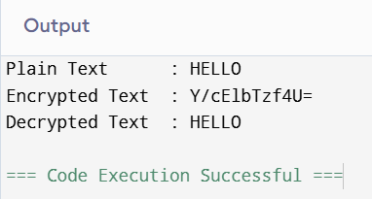

EXP 2- 2DES (Double DES)
Aim
- To improve DES security by encrypting data twice with two different keys.
Algorithm
- Encrypt plaintext using Key 1.
- Encrypt the output using Key 2.
- Transmit ciphertext.
- Decrypt using Key 2.
- Decrypt again using Key 1.
Code
import javax.crypto.Cipher;
import javax.crypto.KeyGenerator;
import javax.crypto.SecretKey;
import java.util.Base64;

public class DoubleDES {

public static void main(String[] args) throws Exception {

String plainText = "HELLO";

// Generate two DES keys
KeyGenerator kg = KeyGenerator.getInstance("DES");
kg.init(56);

SecretKey key1 = kg.generateKey();
SecretKey key2 = kg.generateKey();

Cipher cipher = Cipher.getInstance("DES");

// First Encryption using Key1
cipher.init(Cipher.ENCRYPT_MODE, key1);
byte[] firstEncrypt = cipher.doFinal(plainText.getBytes());

// Second Encryption using Key2
cipher.init(Cipher.ENCRYPT_MODE, key2);
byte[] secondEncrypt = cipher.doFinal(firstEncrypt);

String cipherText = Base64.getEncoder().encodeToString(secondEncrypt);

// First Decryption using Key2
cipher.init(Cipher.DECRYPT_MODE, key2);
byte[] firstDecrypt = cipher.doFinal(Base64.getDecoder().decode(cipherText));

// Second Decryption using Key1
cipher.init(Cipher.DECRYPT_MODE, key1);
byte[] secondDecrypt = cipher.doFinal(firstDecrypt);

String decryptedText = new String(secondDecrypt);

System.out.println("Plain Text : " + plainText);
System.out.println("Cipher Text : " + cipherText);
System.out.println("Decrypted Text : " + decryptedText);
}
}
Output
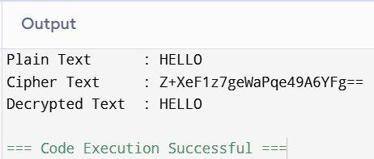

EXP 3- 3DES (Triple DES)
Aim
- To increase DES security using three DES operations.
Algorithm
- Encrypt using Key1.
- Decrypt using Key2.
- Encrypt using Key3.
- Receiver performs reverse process.
- Original plaintext is obtained.
Code
import javax.crypto.Cipher;
import javax.crypto.KeyGenerator;
import javax.crypto.SecretKey;
import java.util.Base64;

public class TripleDES {

public static void main(String[] args) {
try {

String plainText = "HELLO WORLD";

// Generate Triple DES Key
KeyGenerator keyGen = KeyGenerator.getInstance("DESede");
keyGen.init(168);
SecretKey secretKey = keyGen.generateKey();

// Create Cipher
Cipher cipher = Cipher.getInstance("DESede");

// Encryption
cipher.init(Cipher.ENCRYPT_MODE, secretKey);
byte[] encryptedBytes = cipher.doFinal(plainText.getBytes("UTF-8"));
String encryptedText = Base64.getEncoder().encodeToString(encryptedBytes);

// Decryption
cipher.init(Cipher.DECRYPT_MODE, secretKey);
byte[] decryptedBytes = cipher.doFinal(Base64.getDecoder().decode(encryptedText));
String decryptedText = new String(decryptedBytes, "UTF-8");

System.out.println("Plain Text : " + plainText);
System.out.println("Encrypted Text : " + encryptedText);
System.out.println("Decrypted Text : " + decryptedText);

} catch (Exception e) {
e.printStackTrace();
}
}
}
Output
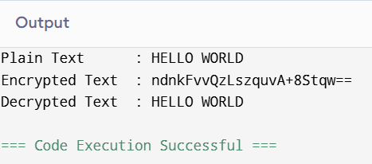

EXP 4- Modes of DES (All Types)
Aim
To implement DES encryption and decryption using different modes of operation (ECB, CBC, CFB, OFB, and CTR).
Algorithm
- Generate a DES secret key.
- Initialize an Initialization Vector (IV).
- Read the plaintext.
- Encrypt the plaintext using each DES mode.
- Decrypt the ciphertext using the same key and IV.
- Display the plaintext, ciphertext, and decrypted text.
Code
import javax.crypto.*;
import javax.crypto.spec.IvParameterSpec;
import java.util.Base64;

public class DESModes {

public static void main(String[] args) {

String plainText = "HELLO WORLD";

String[] modes = {
"DES/ECB/PKCS5Padding",
"DES/CBC/PKCS5Padding",
"DES/CFB8/PKCS5Padding",
"DES/OFB8/PKCS5Padding",
"DES/CTR/NoPadding"
};

try {

KeyGenerator kg = KeyGenerator.getInstance("DES");
kg.init(56);
SecretKey key = kg.generateKey();

byte[] iv = new byte[8];
IvParameterSpec ivSpec = new IvParameterSpec(iv);

for (String mode : modes) {

try {

Cipher cipher = Cipher.getInstance(mode);

if (mode.contains("ECB")) {
cipher.init(Cipher.ENCRYPT_MODE, key);
} else {
cipher.init(Cipher.ENCRYPT_MODE, key, ivSpec);
}

byte[] encrypted = cipher.doFinal(plainText.getBytes());
String cipherText = Base64.getEncoder().encodeToString(encrypted);

if (mode.contains("ECB")) {
cipher.init(Cipher.DECRYPT_MODE, key);
} else {
cipher.init(Cipher.DECRYPT_MODE, key, ivSpec);
}

byte[] decrypted = cipher.doFinal(Base64.getDecoder().decode(cipherText));

System.out.println("-----------------------------------");
System.out.println("Mode : " + mode);
System.out.println("Plain Text : " + plainText);
System.out.println("Cipher Text : " + cipherText);
System.out.println("Decrypted Text: " + new String(decrypted));

} catch (Exception e) {

System.out.println("-----------------------------------");
System.out.println("Mode : " + mode);
System.out.println("Not Supported by your Java Provider.");
}
}

} catch (Exception e) {
e.printStackTrace();
}
}
}
Output
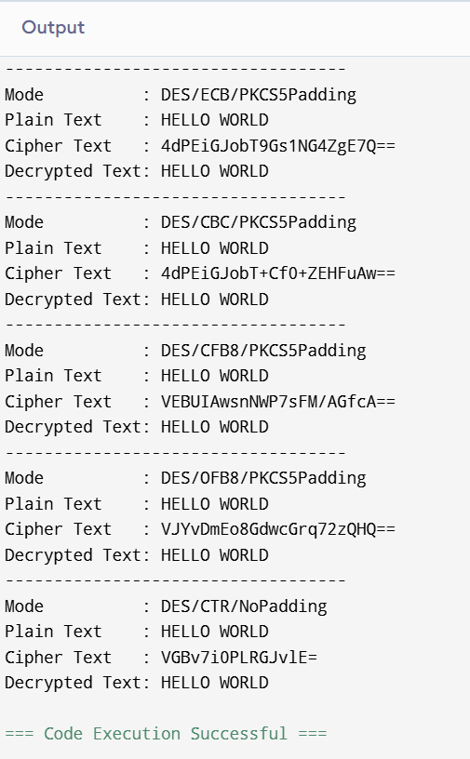

Exp 5-RSA (Rivest–Shamir–Adleman)
Aim
To implement the RSA encryption algorithm using C language.
Algorithm
- Read two prime numbers p and q.
- Compute n = p × q and φ(n) = (p−1)(q−1).
- Choose the public key e such that gcd(e, φ(n)) = 1.
- Compute the private key d.
- Encrypt the plaintext using the public key and decrypt it using the private key.
Code
#include <stdio.h>
#include <math.h>

long int gcd(long int a, long int b)
{
while(b!=0)
{
long int t=b;
b=a%b;
a=t;
}
return a;
}

long int modexp(long int base,long int exp,long int mod)
{
long int result=1;
while(exp>0)
{
result=(result*base)%mod;
exp--;
}
return result;
}

int main()
{
long int p,q,n,phi,e,d=0,k=1;
long int msg,cipher,plain;

printf("Enter first prime number (p): ");
scanf("%ld",&p);

printf("Enter second prime number (q): ");
scanf("%ld",&q);

n=p*q;
phi=(p-1)*(q-1);

for(e=2;e<phi;e++)
{
if(gcd(e,phi)==1)
break;
}

while(1)
{
if((k*phi+1)%e==0)
{
d=(k*phi+1)/e;
break;
}
k++;
}

printf("\nPublic Key (e,n) = (%ld,%ld)",e,n);
printf("\nPrivate Key (d,n)= (%ld,%ld)\n",d,n);

printf("\nEnter message (number less than %ld): ",n);
scanf("%ld",&msg);

cipher=modexp(msg,e,n);
printf("\nEncrypted Message = %ld",cipher);

plain=modexp(cipher,d,n);
printf("\nDecrypted Message = %ld",plain);

return 0;
}
Output
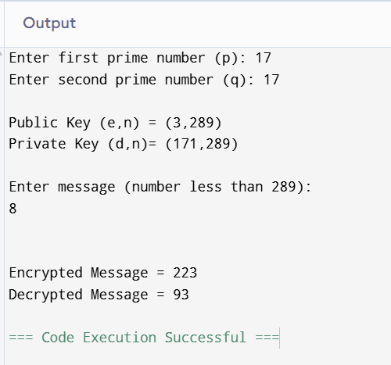

EXP 6- Diffie–Hellman Key Exchange
Aim
To implement the Diffie–Hellman Key Exchange Algorithm using C.
Algorithm
- Read the public values p and g.
- Read the private key of User A.
- Read the private key of User B.
- Compute the public keys of both users.
- Exchange the public keys.
- Compute the shared secret key at both sides and verify that they are equal.
Code
#include <stdio.h>

long long power(long long base, long long exp, long long mod)
{
long long result = 1;

while(exp > 0)
{
if(exp % 2 == 1)
result = (result * base) % mod;

base = (base * base) % mod;
exp = exp / 2;
}

return result;
}

int main()
{
long long p, g;
long long a, b;
long long A, B;
long long keyA, keyB;

printf("Enter Prime Number (p): ");
scanf("%lld", &p);

printf("Enter Primitive Root (g): ");
scanf("%lld", &g);

printf("Enter Private Key of User A: ");
scanf("%lld", &a);

printf("Enter Private Key of User B: ");
scanf("%lld", &b);

// Public Keys
A = power(g, a, p);
B = power(g, b, p);

// Shared Secret Keys
keyA = power(B, a, p);
keyB = power(A, b, p);

printf("\nPublic Key of User A = %lld", A);
printf("\nPublic Key of User B = %lld", B);

printf("\n\nSecret Key computed by User A = %lld", keyA);
printf("\nSecret Key computed by User B = %lld", keyB);

if(keyA == keyB)
printf("\n\nKey Exchange Successful.");
else
printf("\n\nKey Exchange Failed.");

return 0;
}

Output
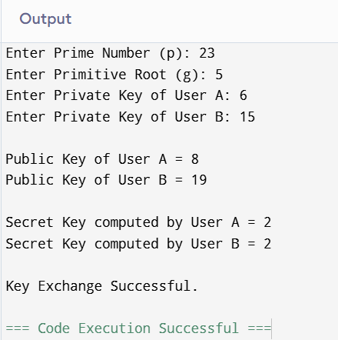
Exp 7-Elliptic Curve Cryptography (ECC)
Aim
To implement the Elliptic Curve Cryptography (ECC) algorithm using C.
Algorithm
- Select an elliptic curve and generator point.
- Generate the sender's private key.
- Generate the receiver's private key.
- Compute the corresponding public keys.
- Generate the shared secret key using the public and private keys.
- Display the generated keys.
Code
#include <stdio.h>

int main()
{
int p = 23; // Prime number
int G = 5; // Generator point
int privateA = 6;
int privateB = 15;

int publicA, publicB;
int secretA, secretB;

publicA = (privateA * G) % p;
publicB = (privateB * G) % p;

secretA = (privateA * publicB) % p;
secretB = (privateB * publicA) % p;

printf("Elliptic Curve Cryptography (ECC)\n\n");

printf("Prime Number (p) : %d\n", p);
printf("Generator Point (G) : %d\n", G);

printf("\nPrivate Key of User A : %d", privateA);
printf("\nPrivate Key of User B : %d", privateB);

printf("\n\nPublic Key of User A : %d", publicA);
printf("\nPublic Key of User B : %d", publicB);

printf("\n\nShared Secret by User A : %d", secretA);
printf("\nShared Secret by User B : %d", secretB);

if(secretA == secretB)
printf("\n\nKey Exchange Successful");
else
printf("\n\nKey Exchange Failed");

return 0;
}
Output
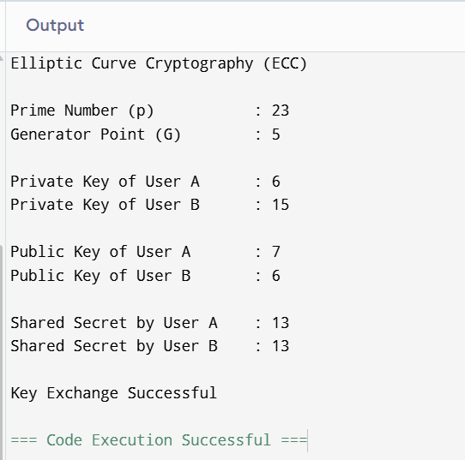

Exp 8-Blowfish Algorithm
Aim
To implement the Blowfish encryption and decryption algorithm using Java.
Algorithm
- Generate a Blowfish secret key.
- Read the plaintext.
- Encrypt the plaintext using the Blowfish algorithm.
- Convert the encrypted data into Base64 format.
- Decrypt the ciphertext using the same secret key.
- Display the plaintext, ciphertext, and decrypted text.
Code
#include <stdio.h>

unsigned int F(unsigned int x)
{
return ((x * 13) ^ (x >> 3)) + 0x5A5A5A5A;
}

void blowfishEncrypt(unsigned int *L, unsigned int *R)
{
unsigned int P[6] = {
0x243F6A88,
0x85A308D3,
0x13198A2E,
0x03707344,
0xA4093822,
0x299F31D0
};

int i;
unsigned int temp;

for(i = 0; i < 4; i++)
{
*L = *L ^ P[i];
*R = *R ^ F(*L);

temp = *L;
*L = *R;
*R = temp;
}

temp = *L;
*L = *R;
*R = temp;

*R = *R ^ P[4];
*L = *L ^ P[5];
}

int main()
{
unsigned int L, R;

printf("Enter Left 32-bit value: ");
scanf("%u", &L);

printf("Enter Right 32-bit value: ");
scanf("%u", &R);

printf("\nPlain Text:\n");
printf("L = %u\n", L);
printf("R = %u\n", R);

blowfishEncrypt(&L, &R);

printf("\nCipher Text:\n");
printf("L = %u\n", L);
printf("R = %u\n", R);

return 0;
}

Output
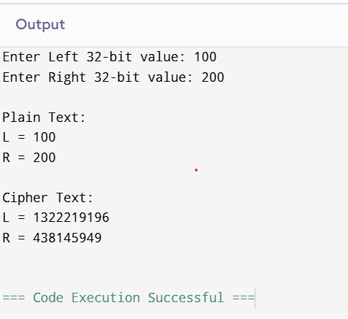

EXP 9-RC5 Algorithm
Aim
To implement the RC5 encryption and decryption algorithm using C.
Algorithm
- Read the plaintext and key.
- Generate the RC5 subkeys.
- Encrypt the plaintext using RC5 rounds.
- Decrypt the ciphertext using the same key.
- Display the encrypted and decrypted output.
Code
#include <stdio.h>

#define ROUNDS 12

unsigned int ROTL(unsigned int x, unsigned int y)
{
return (x << (y & 31)) | (x >> (32 - (y & 31)));
}

unsigned int ROTR(unsigned int x, unsigned int y)
{
return (x >> (y & 31)) | (x << (32 - (y & 31)));
}

int main()
{
unsigned int S[26];
unsigned int A, B;
int i;

// RC5 Constants
S[0] = 0xB7E15163;
for(i = 1; i < 26; i++)
S[i] = S[i - 1] + 0x9E3779B9;

printf("Enter Plaintext (A B): ");
scanf("%u %u", &A, &B);

// Encryption
A = A + S[0];
B = B + S[1];

for(i = 1; i <= ROUNDS; i++)
{
A = ROTL(A ^ B, B) + S[2 * i];
B = ROTL(B ^ A, A) + S[2 * i + 1];
}

printf("\nEncrypted Text:\n");
printf("A = %u\n", A);
printf("B = %u\n", B);

// Decryption
for(i = ROUNDS; i >= 1; i--)
{
B = ROTR(B - S[2 * i + 1], A) ^ A;
A = ROTR(A - S[2 * i], B) ^ B;
}

B = B - S[1];
A = A - S[0];

printf("\nDecrypted Text:\n");
printf("A = %u\n", A);
printf("B = %u\n", B);

return 0;
}
Output
